3GPP TSG RAN WG1 Meeting #125 R1-2604761
Dalian, China, May 18-22, 2026
_____________________________________________________________________Agenda item: 10.8.2
Source: LG Electronics
Title: Discussion on aspects of integration with communication for 6G ISAC
Document for: Discussion and decision
- Introduction
In RAN1 #124bis meeting, the following agreements were made for 6GR ISAC [1]:
Agreement:
- On RS for ISAC, study at least the following aspects, considering sensing performance, resource overhead and impact to communication
  - RS for communication is reused for sensing
  - Enhanced RS for sensing, taking reuse of RS for communication as starting point
    - Note: Part of or all of the RS may be used for communication purpose, and it does not mean the final decision on whether the enhanced RS is used for communication purpose is to be made in this agenda.
  - Dedicated RS for sensing

Agreement:
- Study RE patterns of RS for sensing, considering sensing performance, resource overhead and impact to communication
- Note: enhancements on RS sequence if any will be discussed in agenda 10.8.3

Agreement:
- On measurement for ISAC, study at least the following aspects.
  - Measurement definitions/levels for TRP-side measurement, taking the measurement Levels studied in NR ISAC as starting point
  - Measurement definitions/levels for UE-side measurement
  - Impacts of non-ideal factors on measurement
  - Other aspects are not precluded
  - Note: this discussion may or may not mean there is specification impact

Agreement:
- On measurement report for ISAC, study at least the following aspects and applicable scenarios (e.g., sensing modes, targets, etc.) from RAN1 perspective.
  - Measurement reporting mechanism from UE
    - Option 1A: The UE measurements and/or assistance information if needed from UE can be directly sent to aNB
    - Option 1B: The UE measurements and/or assistance information if needed from UE can be sent to SF
  - Measurement reporting mechanism from aNB
    - Option 2A: The aNB measurements and/or assistance information if needed from aNB can be directly sent to UE
    - Option 2B: The aNB measurements and/or assistance information if needed from aNB can be sent to SF
  - The study may require cross-WG coordination.
  - Note: combination of multiple options is not precluded.
  - Note: measurements in each option may be different

Agreement:
- On measurement report for ISAC, study impacts from at least the following aspects from RAN1 perspective
  - Measurement reporting mechanism
    - E.g., Periodic, semi-persistent, aperiodic, event-triggered report as starting point
    - Reporting signaling e.g., L1, L2, higher layer, etc.
  - Other aspects are not precluded
  - The study may require cross-WG coordination.
Based on the above agreements, companies are encouraged to provide inputs following the plan for RAN1 #125 [2].
- Usage scenarios for sensing assisted communication.
Note: this doesn’t mean we want to directly specify anything. We need RAN1 views on communication assistance which is required by RAN. To justify a usage scenario, either evaluation (10.8.1) or analysis can be considered.
Note: after clarification on the usage scenarios, it is possible that they are merged with object detection/tracking in respective discussions.
- RS design
  - Please elaborate designs on sensing RS especially the RE patterns.
  - Please provide evaluations/analysis.
- Measurement/report
  - Measurement definitions/levels for TRP-side and UE-side measurements, taking into account the impact of non-ideal factors.
  - Views on key issues of measurement reporting mechanisms.
- Based on discussions in this meeting (though no agreements yet), the inputs on the following aspects can be considered which is up to each company.
  - Resource allocation/multiplexing
  - Phase continuity within a CPI
  - Beam related sensing operations
  - Interference handling
  - Power control
  - Timing advance
  - Sensing Tx/Rx node selection, if any, from RAN1 perspective
  - Start/end/activation/deactivation of sensing operations, if any, from RAN1 perspective
In accordance with the work plan, we provide views on the study on usage scenarios for sensing assisted communication, RS design, measurement/ reporting, as well as other issues for study.

- Discussions
  - Usage scenarios for sensing assisted communication
The RAN study on 6G scenarios and requirement clarified the sensing related use cases including communication assistance in the [3] as follows:

5.4.4 Sensing
Editor note: More sensing use cases can be included depending on further discussion.
The 6GR and 6G RAN architecture shall at least support use cases of
- detection and/or tracking of passive objects, at least including UAVs, human, vehicles and AGVs
- communication assistance.
Sensing assisted communication can be understood as an operation where sensing measurements are used to assess whether the assumptions or conditions underlying existing communication PHY procedures remain valid, and where the communication configuration is maintained, updated, reset, or fallbacks to a more robust configuration depending on the sensing outcome. Based on this understanding, sensing assisted communication may be considered for a variety of communication PHY procedures where the validity or efficiency of the procedure depends on the surrounding physical environment, UE/object geometry, mobility state, blockage condition, or interference condition. Table 1 provides examples of candidate usage scenarios.
Table 1. Examples of usage scenarios for sensing assisted communication
Use case | Sensing information | RAN1-relevant application | Expected benefit
Predictive handover management | Obstacle location, blockage prediction, UE trajectory | candidate beam activation, measurement configuration | Reduced outage and handover failure
Context-aware resource allocation | Shadowed regions, interference zones, UE/object density | Beam/resource/power allocation, link adaptation, spatial reuse | Improved aggregate throughput
Geometric multipath exploitation | EO geometry, scattering characteristics, reflected path information | EO-assisted beam selection, initial access, data transmission | Improved NLoS coverage and data rate
Echo mitigation | Echo-generating object location, delay/angle of long-delay paths | Spatial nulling, beam avoidance, RS/link adaptation | Reduced BER and ISI
Dynamic coverage optimization | Real-time RF map updates, moving blockers, coverage holes | Beamwidth/beam direction adaptation, TCI update, measurement reconfiguration | Improved coverage probability
Sensing-derived information may provide geometry-aware and environment-aware assistance for communication PHY procedures. For example, object location, UE trajectory, and predicted blockage can be used to prepare alternative beams or TRPs before LoS degradation occurs. Shadowed regions and interference zones can assist resource, power, beam, and link adaptation. Environmental object geometry and scattering characteristics can be used to identify useful reflected or scattered paths for NLoS communication. In addition, delay/angle information of long-delay paths can assist echo mitigation, while real-time RF map updates can support dynamic coverage adaptation.
From the RAN1 perspective, further study may be needed to identify which sensing measurement information is beneficial for each communication procedure, how such information is obtained and represented, and how it can be used to assist PHY-layer configuration decisions. Therefore, it may be beneficial for RAN1 to identify representative sensing assisted communication usage scenarios and clarify, for each scenario, the associated communication PHY procedure, the relevant sensing measurement information, and the possible action taken based on the sensing-assisted assessment.
However, it is noted that discussions on 6G communication system design are still ongoing in parallel. As a result, the specific aspects of the communication system to be supported by sensing are not yet fully established. The intended objectives of such support also remain unclear. In this context, it may be desirable to limit the scope of sensing-assisted communication studies at the current stage Therefore, it is preferred, on a best-effort basis, to study on the utilization of sensing measurement/reporting for communication system support. Further extension of sensing-assisted communication usage scenarios can be considered in a later stage. Such extension may follow the progress and clarification of other communication-related agendas.
Proposal 1: RAN1 studies and identifies whether/which communication procedures can benefit from sensing-derived information.
Proposal 2: RAN1 studies whether/how sensing signal/measurement/report can assist communication system.

  - RS design
    - Sensing reference signal
This section discusses the analysis of existing communication signals as sensing signals, considerations on sensing RS patterns, and resource configuration aspects.
A key consideration for RAN1 in the context of ISAC functionalities is how sensing support can be realized within the radio access network, taking into account that work items on new physical layer frameworks for 6GR are being progressed under other agendas. While leveraging the existing NR physical layer framework may provide a useful starting point, modifications or extensions to the framework are acceptable where justified by 6G sensing requirements. Fundamentally, sensing serves a purpose that is distinct from communication, as it aims to extract physical characteristics of the propagation environment, rather than to enable reliable data transmission.
At the same time, from a standardization and system evolution perspective, the introduction of new sensing dedicated signal design (including RS pattern, waveform, etc) need to be studied. Considering compatibility with communication framework and the desire to minimize changes to the existing framework, reusing and enhancing of existing communication signals represents an efficient and pragmatic option. In particular, a sensing‑specific waveform may require further study, as it may involve additional transmitter and receiver processing chains, new numerology and synchronization assumptions, and additional considerations on multiplexing with communication signals. As a result, it is considered beneficial to study the feasibility, potential, and limitations of existing communication signals when applied to sensing use cases, as well as to identify what types of enhancements would be required to better accommodate sensing requirements.
Observation 1: It is beneficial for sensing waveform to be aligned with 6G baseline communication waveform in terms of ISAC system implementation complexity.

Given these considerations, and assuming the use of (DFT‑) OFDM as a baseline waveform for sensing, sensing RS pattern design based on the existing communication RS can be considered. In this context, three approaches can be considered: reusing or enhancing existing communication RS patterns or designing new RS patterns for sensing. Each approach involves different trade‑offs in terms of sensing performance, signaling overhead, and impact on the communication framework.
Proposal 3: If (DFT-s-) OFDM is agreed as a sensing waveform, RAN1 studies the type of a sensing RS of (DFT-s-) OFDM symbol.
Alt 1. Reuse the 6G communication RS pattern
Alt 2. Enhance the 6G communication RS pattern
Alt 3. Design a new RS pattern for sensing

In addition, any modification or enhancement of communication RS patterns for sensing purposes may have implications beyond sensing itself and may impact other aspects of the communication system. Such impacts include potential changes to communication performance, scheduling behavior, and resource management. Therefore, studies on sensing RS pattern design and enhancement should also consider their interaction with other 6G design agendas, and coordination with relevant 6G work items may be required to properly assess system-level evaluation.
Proposal 4: If 6G communication RS pattern is enhanced for sensing, RAN1 needs to study the impact of RS enhancement to the communication system, which may need cooperation with the relevant 6G agenda.

It is necessary to study how existing communication RSs can be reused or adapted as sensing RSs. Different communication RSs employ different RS patterns in terms of time-frequency placement, density, and configurability, which may introduce both opportunities and limitations when applied to sensing.
Demodulation Reference Signal (DMRS) and Phase Tracking Reference Signal (PTRS) are tightly associated with scheduled PDSCH or PUSCH transmissions and follow RS structures that are coupled with data transmission. Their dependence on data scheduling and limited independent configurability may constrain their use for persistent and measurement-oriented sensing transmissions. At the same time, it is possible that, under certain configurations or usage scenarios, DMRS and PTRS could support limited sensing functionality. Therefore, additional studies are needed to assess the extent to which these signals can be leveraged or enhanced to support sensing requirements.
Similarly, the Synchronization Signal / PBCH Block (SSB), despite its fixed structure and primary role in broadcast and initial access, may enable certain sensing operations under constrained conditions. However, its fixed bandwidth and semi-static time-frequency location limit flexibility in terms of delay resolution, repetition, and coherent observation duration. As such, further studies are required to understand whether SSB can support sensing beyond limited use cases, or whether modifications or complementary mechanisms would be needed to improve its suitability for sensing.
Positioning-oriented reference signals, such as Positioning Reference Signal (PRS) and positioning Sounding Reference Signal (SRS), employ structures that are measurement-centric, configurable, and suitable for multi-node observation, which are generally well aligned with sensing requirements. These signals may therefore support more advanced sensing functionality from a technical perspective. However, since positioning-specific reference signals are not currently a primary focus in ongoing 6G RAN discussions, which could introduce prioritization and coordination considerations.
SRS and Channel State Information Reference Signal (CSI-RS) are designed for communication channel sounding and typically prioritize overhead efficiency and flexibility. Their configurations, such as sparse frequency-domain mapping and limited coherent processing intervals, may constrain sensing performance in terms of delay, Doppler, and spatial resolution. Nevertheless, due to their high configurability and integration within the NR framework, SRS and CSI-RS remain attractive candidates for sensing support. In particular, uplink SRS may enable multi-UE based sensing observations, while downlink CSI-RS may provide flexible control over transmission power, beamforming, and time-frequency placement, which could be beneficial for BS-centric sensing scenarios.
Additional to consideration above, if communication RS patterns are reused for sensing, it is necessary to distinguish whether only the RS pattern is reused, or whether the RS transmitted within an actual communication OFDM symbol is reused as a sensing RS. Reusing RSs within communication symbols can minimize additional symbol overhead and maintain tight integration with the communication framework, but it may limit sensing performance due to power sharing and possible interference with communication signals. In addition, the sensing service area may be restricted to the communication area, and the sensing service can be provided only when there are data payload to be transmitted for communication service. In contrast, allocating dedicated symbols for sensing while reusing communication RS patterns allows full utilization of bandwidth and transmit power for sensing. It can also improve performance predictability and the sensing service should be available whenever needed regardless of the communication service. All these benefits, of course, come at the cost of additional time-domain overhead and reduced communication capacity. Therefore, further studies are needed to evaluate the trade-offs between these approaches and their impact on both sensing and communication performance.
Proposal 5: If 6G communication RS pattern is reused, RAN1 needs to identify the type of symbol to include the sensing RS.
Alt 1. Transmitted in 6G communication symbol
Alt 2. Transmitted in a separate sensing symbol
Alt 3. Both depending on use cases

Communication RS patterns are typically defined by a set of parameters in the time and frequency domains, such as RS symbol positions, periodicity, density, time-frequency placement, and port or sequence configurations. As discussed above, these parameters for existing communication signals may be constrained by communication-centric design objectives, including scheduling flexibility, overhead control, and channel estimation requirements.
To satisfy sensing requirements, it may be necessary to either extend the existing RS patterns or introduce additional parameters to better support sensing operation. One approach is to extend the configuration parameters of existing communication RS patterns, for example by allowing more flexible placement, repetition, or sensing-oriented parameterization. This approach has the advantage of maintaining close compatibility with existing communication signals and minimizing the introduction of new signal structures. However, extending communication RS parameters may increase configuration complexity and could have implications for communication performance, requiring careful evaluation.
Alternatively, communication RS parameters can be kept unchanged to preserve communication compatibility, while additional sensing RS patterns can be additionally configured to meet sensing performance requirements. This approach allows sensing RS design to be more explicitly optimized without impacting communication RS behavior, but it may introduce additional signaling overhead and require separate resource management for sensing.
In the case that existing RS patterns are enhanced for sensing, RAN1 can study the pros and cons of the uniform and non-uniform RS patterns. From the sensing Rx processing point of view, Doppler shift can be more easily obtained from the equi-distance sensing RS patterns rather than RSs of different intervals in time domain. For example, in NR slot structure comprising of 14 OFDM symbols (normal CP mode), there are differences in the CP lengths of OFDM symbols within a slot. The CP length of symbol index 0 and 7 is much larger than those of other symbols. If equi-distance property of sensing RS signals in time domain is required, sensing RSs can be transmitted in OFDM symbol per sub-frame within CPI, or one sub-frame can be considered as one CPI duration so that RSs within one sub-frame have same distance from each other.
Proposal 6: If 6G communication RS pattern is enhanced, RAN1 needs to study the exact method of enhancement.
Alt 1. Extension of 6G communication RS parameters
Alt 2. Addition of new RS pattern to 6G communication RS

    - Non-uniform reference signal pattern
For CP-OFDM based sensing, the RS pattern in the frequency domain is directly related to the sensing performance in the range domain. In particular, when the reference signal is mapped with a comb-type pattern having a uniform spacing in the frequency domain, the sampled frequency response has a periodic structure. As a result, after processing the sampled frequency-domain response for range estimation, the corresponding range-domain response may exhibit repeated peaks. These repeated peaks may make it difficult to distinguish the true target range from ambiguous range candidates, especially when the target distance is beyond the maximum unambiguous range associated with the frequency-domain sampling interval.
The maximum unambiguous range depends on the effective spacing between the REs in the frequency domain. With a uniformly spaced comb-type pattern, the periodicity of the RE positions may lead to a periodic ambiguity structure in the range domain. Although such a comb-type pattern is attractive from the perspective of overhead reduction and multiplexing with communication signals, the resulting ambiguity behavior needs to be carefully considered for ISAC target detection. This issue is particularly relevant when the sensing operation is expected to support a wide range of target distances while maintaining limited reference signal overhead.
One possible direction to mitigate the range ambiguity is to consider non-uniform RE patterns in the frequency domain. By avoiding a strictly periodic RE placement, the periodic ambiguity structure in the range-domain response can be reduced. In other words, a non-uniform RE pattern can provide additional degrees of freedom to shape the ambiguity characteristics while maintaining compatibility with the CP-OFDM based resource grid. Such a design direction can be considered without changing the basic CP-OFDM waveform assumption, and therefore it is suitable for further study under the current ISAC reference signal design framework. Figure 1 shows comparison between delay domain ambiguity function of uniform and non-uniform RE pattern.
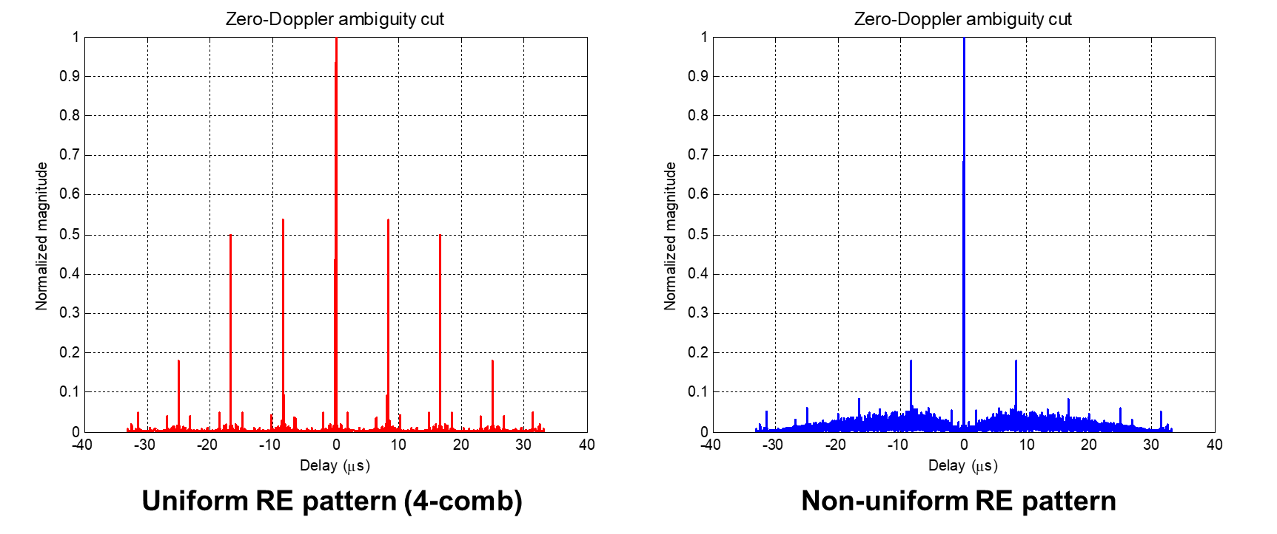
Figure 1. The zero-Doppler ambiguity functions of reference signals with different RE patterns

Observation 2. Comb-type RE mapping with a uniform spacing in the frequency domain may cause range ambiguity in target detection.
Observation 3. A non-uniform RE pattern in the frequency domain can mitigate range ambiguity in target detection.
Proposal 7. RAN1 studies non-uniform RS RE patterns in the frequency domain for mitigating ambiguity problems in target detection.

  - Measurement and Assistance information
    - Measurement metrics and reporting
This section discusses the down-selection of sensing measurement levels defined in 5G‑A, measurement reporting methods, and additional sensing measurements depending on different sensing modes.
As the results of the 5G-A ISAC study item, In the TR 38.765 [4], various measurement levels, options and metrics were defined as follows:
- Level A: Raw data per Tx antenna port per OFDM symbol per RX antenna port per TRP for a given time stamp
- Option A1: Amplitude and phase samples in time/delay domain of the estimated channel, i.e., Amplitude and phase values of channel impulse response
- Option A2: Amplitude and phase per subcarrier in frequency domain of the estimated channel
- Level B: Amplitude and phase profile of delay, and/or Doppler, and/or angle per TRP for a given time stamp by using window(s) of the consecutive samples in at least one profile of delay, and/or Doppler and/or angle domain
- Option B1: Delay-Doppler profile per Tx antenna port per Rx antenna port, which includes the amplitude and phase samples distributed across different delays and Doppler shifts.
- Option B2: Delay-Angle profile per Tx antenna port per OFDM symbol, which includes the amplitude and phase samples distributed across different delays and spatial angles (e.g., Angle of Arrival).
- Option B3: Delay-Doppler-Angle profile per Tx antenna port, which includes the amplitude and phase samples distributed across delay, Doppler, and angle domains.
- Option B4: Delay profile per Tx antenna port per OFDM symbol per Rx antenna port, which includes the amplitude and phase samples distributed across different delays.
NOTE: Level B is applicable for either LCS or GCS
- Level C: per detected path/point measurements per Tx antenna port per TRP which may be reflected/scattered from scattering point(s).
- Option C1: Delay/range, Doppler/radial velocity, one or multiple 3D angles, metric related to power, and confidence metric per detected path for a given time stamp. A path is associated with one set {delay/range, Doppler/radial velocity, metric related to power, and confidence metric}, and one or multiple 3D angles.
- Option C2: Doppler/radial velocity, position, metric related to power, and confidence metric per detected path for a given time stamp. A path is associated with one set {Doppler/radial velocity, metric related to power, and confidence metric}, one or multiple positions
- Option C3: Delay/range, Doppler/radial velocity, 3D angle, metric related to power, and confidence metric per detected path for a given time stamp. A path is associated with one delay, and one or multiple sets {Doppler/radial velocity, 3D angle, metric related to power, and confidence metric}
- Option C4: Delay/range, Doppler/radial velocity, 3D angle, metric related to power, and confidence metric per detected point for a given time stamp. A point is associated with one range/delay, one Doppler/radial velocity, one 3D angle
- Option C5: Position, radial velocity, metric related to power, and confidence metric per detected point for a given time stamp. A point is associated with one position, one radial velocity.
NOTE: Position can be defined in either LCS or GCS. Angle can be defined in either LCS or GCS. 3D angle refers to a pair of horizontal and vertical angles.
- Level D: Object/target level measurement per gNB.
- Option D1: Only one value set {position, 3D velocity, metric related to power (if applicable), confidence metric} in GCS and optional radial velocity for a given time stamp is reported for a detected object/target. The association of multiple measurements across different time stamps for the same detected object/target is not reported.
- Option D2: Only one value set {position, 3D velocity, metric related to power (if applicable), confidence metric} in GCS for a given time stamp is reported for a detected object/target. The association of multiple measurements across different time stamps for the same detected object/target is reported.
- Option D3: One or more value sets {position, 3D velocity, metric related to power (if applicable), confidence metric} in GCS for a given time stamp are reported for a detected object/target. The association of multiple measurements across different time stamps for the same detected object/target is reported.
- Option D4: One or more value sets {position, 3D velocity, metric related to power (if applicable), confidence metric} in GCS and optional radial velocity for a given time stamp are reported for a detected object/target. The association of multiple measurements across different time stamps for the same detected object/target is not reported.
NOTE: From physical layer perspective, gNB can associate with one or multiple TRPs for Level D.
NOTE: The metric related to power may be different from those defined for communication and between Level C and Level D
NOTE: For Level A/B/C, Tx antenna port means reference signal antenna port for sensing purpose.
The definition on time stamp from existing specifications, e.g., TS 38.455, TS 38.355, TS 37.355 are reused as baseline.
Table 2 summarizes the payload sizes for each measurement level from [5].
Table 2 the payload size for each Level/option
Level | Option | Payload size (bits)
 |  | minimum | medium | Maximum | Max-FFS
A | A1, A2 | 1.29G | 25.7G | 115.9G | 115.9G
B | B1 | 113.2M | 3.67G | 16.5G | 50.8G
 | B2 (32) | 56.6M | 1.84G | 8.26G | 25.4G
 | B2 (432) | 764M | 24.8G | 111.6G | 343.0G
 | B3 (32) | 56.6M | 1.84G | 8.26G | 25.4G
 | B3 (432) | 764M | 24.8G | 111.6G | 343.0G
 | B4 | 113.2M | 3.67G | 16.5G | 50.8G
C | C1, C2, C3, C4, C5 | 7.2K | 28.8K | 28.8K | 28.8K
D | D1 | 1.68K | 3.36K | 3.36K | 3.36K
 | D2 | 1.92K | 3.84K | 3.84K | 3.84K
 | D3, D4 | 2.48K | 4.96K | 4.96K | 4.96K

It can be observed that among the measurements level above, Level A (raw data) and Level B (amplitude/phase profiles) can provide rich information for SF-side processing; however, they may lead to large overhead, ranging from hundreds of megabits to tens or even hundreds of gigabits per report, depending on options. Such payload sizes make Level A and B too much burden for regular reporting, especially when considering frequent sensing updates, multi-TRP operation, or centralized processing. In contrast, Level C achieves a significant reduction in payload size by reporting per-path or per-point measurement results instead of raw or profile-level data. The resulting payload size is on the order of several kilobits to several tens of kilobits, which is several orders of magnitude smaller than Levels A and B. This makes Level C a practical baseline for 6G sensing measurements from both signaling and system design perspectives.
Level D further reduces the payload size by reporting object-level sensing results. While its payload size is comparable to or even smaller than that of Level C, Level D inherently requires additional processing such as data association, tracking, and fusion across paths, points, or TRPs. Also, a coarse association indicating measurements come from the same physical object is needed for consistent measurement and reporting. As such processing may not always be available or desired at the sensing node, Level D is better suited as an optional measurement level, allowing capable implementations
Power-related metric for level C/D are essential for monitoring the sensing link between the sensing entities and the target object. Existing radio link monitoring metrics defined in TS 38.215 [6], including RSRP and RSRPP, can serve as a basis. However, from the perspective of false alarms and missed detections, measuring received power at the resource level may be insufficient for accurately monitoring the sensing link between the BS and the object. To support sensing-based operations, new L1-level measurements may be considered that can effectively represent the quality of a target or detected path.
For example, it can be measured as the ratio between the received power of the target (or detected) path and that of non-target signals, including background channel and/or noise averaged over measurement resources. In cases with multiple target paths, the measurement may be based on the average or minimum received power of those paths. These values can be reported as a difference between the received power of target and non-target signals, providing insight into signal dominance and interference conditions. To identify target paths, the measurement range in delay, Doppler, or angle domains can be (pre-)configured by higher layers. Within this range, sensing-specific SINR can be measured and reported based on detectable points.
In addition, UE-side measurement may need to consider UE capability limitations. Compared to an aNB/TRP, a UE may have more limited processing capability, and thus measurements requiring additional processing, such as Level D object/target-level measurements, may impose non-negligible burden on the UE. Moreover, due to the smaller antenna aperture size at the UE, the performance of angle-of-arrival (AoA) estimation may be inherently limited. In NR, DL-AoD positioning utilizes transmitter-side angle information, avoiding the need for explicit AoA estimation at the UE. In contrast, UL-AoA positioning relies on AoA measured at the receiving TRP, which can exploit its larger antenna array and higher estimation accuracy. In this context, it may be preferable that UE-side angular-related measurements are not based on explicit AoA estimation.

Observation 4: 5G-A ISAC measurement level A and B require huge amount of signaling overhead, compared to level C and D.
Proposal 8: 5G-A ISAC measurement level C is considered as baseline, and level D as optional for 6GR sensing measurement.

In general, measurement reporting can be categorized into periodic, aperiodic, and event-triggered reporting. Periodic reporting provides measurements at a configured interval and may be suitable for maintaining regular awareness of sensing conditions, particularly when coarse-grained measurement levels or long-term statistics are considered. However, when finer measurement levels or detailed sensing information are involved, periodic reporting may introduce unnecessary overhead if sensing conditions remain stable over time.
Aperiodic reporting, which is triggered by a request from the SF or maybe any sensing entities, may offer greater flexibility in such cases. This type of reporting can be aligned with specific sensing operations or evaluation needs, allowing measurements corresponding to particular measurement options or levels to be collected on demand. This may be beneficial when higher-resolution measurements are required, or when reporting overhead needs to be tightly controlled.
Event-triggered reporting is another aspect to be studied, especially in relation to sensing-specific conditions that may not be directly reflected in communication link performance. Depending on the measurement level or option, certain changes in sensing conditions—such as variations in measurement quality, detectability, or consistency—may warrant immediate reporting. Defining appropriate triggering criteria that are meaningful for sensing measurements is therefore an important topic for further investigation. In addition, conditional measurement reporting, where reporting is enabled only when predefined conditions are satisfied, may help balance sensing performance and signaling efficiency. Such conditions may be associated with specific measurement levels or options, for example when reporting is required only if certain measurement quality thresholds are met or if changes exceed a configured level. Studying how different reporting types can be supported and combined, while accounting for the characteristics of sensing measurement levels and options, is relevant to enable efficient and flexible sensing operation.
Proposal 9: RAN1 studies the types of the measurement report.

Regarding the measurement reporting, it may not always be necessary to report all the sensing results that Rx module can measure. The extent of range, velocity or the direction of interest can be provided by the sensing service consumer from the beginning. Reducing the amount of the reported measurements also helps to reduce the unnecessary power consumption and resource overhead. In this sense, the extent of the delay(range), Doppler(velocity) and/or direction(angle) to be reported can be (pre-)configured by SF or BS. Such (pre-)configuration is consistent with the conclusion in SA2 TR 23.700-14 [7], which describe that, based on the target sensing service area, the SF selects sensing entity(ies) and provides the information required for sensing; this information can naturally include the reporting extents described above.
In addition to such extent for reporting, the minimum value of the received sensing signal power, RCS, and Doppler frequency level can also be (pre-)configured. Only measurement values larger than the (pre-)configured values can be reported so as not to report a noisy component as a meaningful sensing result. Furthermore, a specific measurement range and/or time-frequency grid with defined granularity can be configured to help the sensing Rx identify the target measurement region. Given such (pre-)configuration above, there can be additional power saving by reporting only the interested measurement of delay, Doppler, and/or angle values. There can be (pre-)configured prioritized extents of such measurements, so that sensing Rx can report the relevant measurements step-by-step according to the prioritization. In such case, sensing Rx can report e.g. the delay measurement per each interested angle extent, or the angle measurement per each interested delay extent, and so forth.
Proposal 10: RAN1 studies how to reduce the signaling overhead for the measurement report.

As the sensing entities and/or the target object can move, RAN1 needs to consider the ‘sensing handover’ operation similar to the communication handover. The sensing handover issue happens in tracking of the detected object. There are some types of sensing handover operations. One is the switching of the sensing entities due to the mobility of the sensing entities and/or the target object. The other one is the switching of the sensing modes – e.g., switching from bistatic to monostatic sensing or vice versa.
Those handover issues are mainly RAN2 issues, but RAN1 can study the required measurement and report to help the decision of the sensing handover. For example, the sensing entities can measure and report the RSRP of the scattered sensing signals or the estimated distance from the target object. The RSRP/distance measurement results of monostatic sensing and bistatic sensing can be used for switching either sensing Tx/Rx or switching the sensing modes. As the tracking of a specific target object is of interest, the RSRP/distance or the estimated RCS can be measured only on the signals scattered by the target object.
Proposal 11: Study measurement reports for Mobility support.

As mentioned above, the measurement Levels/Options defined for gNB monostatic sensing can be reused in 6G sensing; however, the physical interpretation of the measurement metrics and the required assistance information could be extended to account for the bistatic characteristic that separation between sensing transmitter and receiver.
Assuming a monostatic configuration, the target localization problem is addressed by finding the intersection of a sphere (the locus of constant range) and a ray (the locus of constant AoA), as depicted in the left of Fig. 3 (for the 2D space).
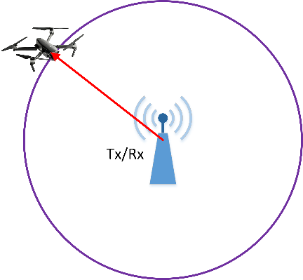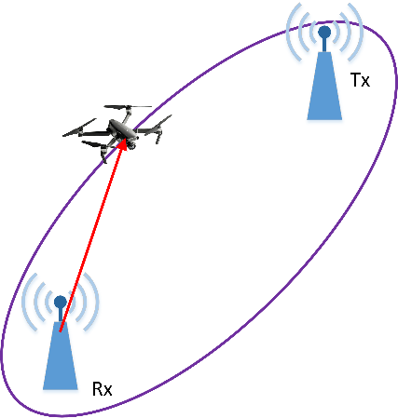
Figure 2 Target localization in monostatic (left) and bistatic (right) configurations
It is evident, that to localize a target in 3D space, one simply requires a transformation from the spherical coordinates into the Cartesian coordinates. While the radial velocity is not directly used for spatial localization, it represents a critical target feature. In addition to providing Doppler-based discrimination from static clutter, the velocity estimates enable trajectory prediction and enhances the performance of tracking filters.
Observation 5: Within a monostatic configuration, the localization of a target in 3D physical space may require the simultaneous estimation of four parameters: target range, radial velocity and both azimuth and zenith angles.

Assuming a bistatic configuration, the target localization problem is addressed by finding the intersection of an ellipsoid (the locus of constant bistatic range) and a ray (the locus of constant AoA), as depicted in the right panel of Figure 2 (for the 2D space).
It is worth noting that this problem is mathematically more complex than the spherical-to-Cartesian transformation required by a monostatic configuration. Furthermore, while bistatic velocity represents a critical target feature, it is more challenging to interpret than the radial velocity, as it depends on the target’s motion relative to the bistatic baseline.
Observation 6: Within a bistatic configuration, the localization of a target in 3D physical space may require the simultaneous estimation of four parameters: bistatic range, bistatic velocity and the AoA defined by the azimuth and zenith angles at the receiver.

In contrast to most traditional radar systems, ISAC systems are characterized by the dense deployment of sensing entities. This implies that the localization problem can be resolved through multiple sensing links without need for AoA estimates. Assuming a monostatic configuration, once the target range estimates from several reference nodes are available, the localization problem can be addressed by finding the intersection of spheres, as depicted in the left panel Figure 3. Analogously, assuming a bistatic configuration, once the bistatic range estimates from several pairs of reference nodes are available, the localization problem can be addressed by finding the intersection of ellipsoids, as depicted in the right panel of Figure 3.
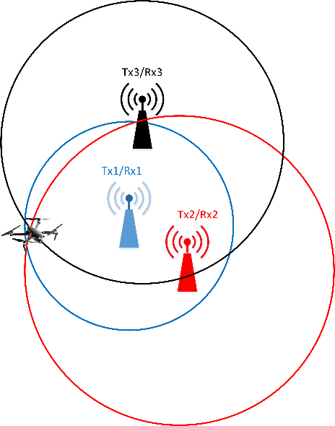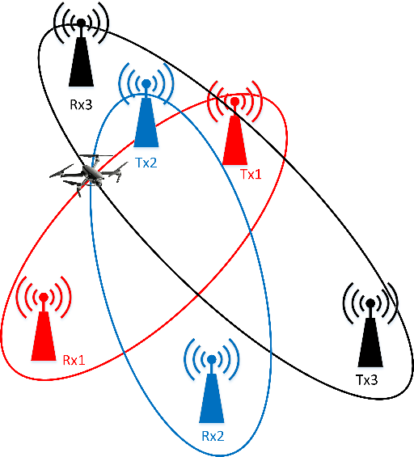
Figure 3 Target localization utilizing range or bistatic range estimates from multiple sensing links in monostatic (left) and bistatic (right) configurations
While localization accuracy is potentially enhanced by utilizing range or bistatic range estimates from multiple sensing links, several challenges must be addressed. A primary issue stems from geometric ambiguity and the appearance of multiple intersection points. Since the accuracy of range and bistatic range estimates is finite, the corresponding spheres or ellipsoids may intersect at more than one point, even for a single target. Furthermore, especially in cluttered environments, each sensing link may produce more detected objects than the true number of targets, leading to potential false associations and ghost targets. In other words, to accurately localize a target using multiple sensing links, one must resolve the association problem.
There are commonalities between sensing and positioning technique, which can be exploited for sensing. In bistatic sensing, the range measurement is done by the ‘bistatic delay.’ The bistatic delay is measured as the time difference between the target channel propagation delay and the sensing Tx-sensing Rx LOS path propagation delay by the sensing Rx. In this sense, the bistatic delay is similar to the measurement of RSTD in positioning technique. So, the definition of RSTD or RTOA used in positioning measurement can be reused for the timing measurement for multi-TRP-to-UE bistatic or UE-to-multi-TRP bistatic sensing respectively. The sensing Rx can simply report the time difference between the first and the n-th tap delay in channel estimation for this purpose.
Observation 7: The details of the measurement metric for monostatic and bistatic sensing may be different.
Proposal 12: RAN1 studies the detailed measurement method of monostatic and bistatic sensing.

    - Assistance information
This section discusses additional assistance information that may be reported alongside sensing measurements to support sensing entity selection, target identification, classification and etc.
In addition to the measurement reports, sensing Rx can report to SF the information related to the measurement. For example, sensing Tx can report the sensing signal Tx power so that the reported measurement on the received signal power can be properly interpreted by SF to identify the detected objects. Moreover, for monostatic sensing, the transmitted sensing signal can be directly received by Rx antenna almost without path loss, which may significantly degrade the detection performance based on the relatively very low reflected sensing signal. This self-interference level needs to be minimized, and is critical for sensing performance. SF can request the level of self-interference by (pre-)configuring the required self-interference level for monostatic sensing. As a sensing entity may have different capability in terms of the self-interference cancellation, it can report the self-interference level, which was measured at the Rx antenna side.
Additional information observed at the sensing Rx can be provided to support object identification and classification. Such information may include Rx power level, RCS, delay, Doppler, and angular behavior, as well as their stability or variation over time and frequency. In addition, sensing Rx may observe polarization-dependent matrix associated with the detected targets. The availability of such information can help the SF to better distinguish target objects from background components and to improve the reliability of detection/tracking/classification results.
One of the purposes of the assistance information is to assist the sensing entity selection by BS or SF (sensing function). For example, the sensing entities can be selected based on the distance from the TSA. To help BS to select appropriate UE as sensing Tx or Rx to achieve better sensing performance, UE may report to BS the distance from TSA, or the received signal power using the receiving beam towards TSA. BS can select UE based on the measurement report from UE, or configure the Tx power of the sensing signal transmitted by UE. Another possibility is that BS can select UE that has LOS path from BS. This kind of assistance information can also be studied in RAN1. All the operations above assumes that TSA information is given to BS or UE from SF or another sensing entity. The other way of using e.g., RSRP from TRP is that UE can select the best TRP that is expected to provide best bistatic sensing performance, based on the measured RSRP of each TRP. RAN1 needs to study what kind of assistant measurement information can also be helpful for sensing performance.
BS/TRP or UE can report the information about the Tx/Rx parameters that are used for the sensing operation, such as follows:
Sensing signal configuration and transmission context
- Sensing signal resource configuration (PRI, CPI, number of sensing resources within CPI, duration of the sensing signal, bandwidth of sensing signal, waveform type, polarity, etc.)
Antenna, beam, and RF characteristics
- Antenna configuration (antenna aperture size, number of antenna element, spacing between antenna element, boresight, interleaved/burst antenna elements for Tx/Rx, etc.)
- Tx/Rx beamwidth used for sensing signal Tx/Rx
- Self-interference level between Tx and Rx antennas
- Self-interference canceling capability
Sensing environment and deployment context
- Unique ID of the sensing entity (Tx or Rx) and location of sensing entity
- Background clutter level or interference characteristics observed at sensing Rx
Target-related characteristics and sensing observables
- Information to assist object identification (Rx power level (RSRP), RCS, polarization matrix, etc.)
- Availability of sensing signal Tx/Rx on the configured resource
- Whether the detected entity is a 3GPP entity or not
- SMU (sensing measurement unit)-related information (SMU ID, estimated location of SMU, etc.)
Observation 8: Assistant information in addition to the measurement report should assist SF to further identify/classify the detected object.
Proposal 13: Study what assistance information related to the measurement needs to be additionally reported.

  - Physical layer procedure
This section discusses physical-layer procedures for integrating sensing with communication, including sensing-aware beam management, measurement gap configuration, interference management, timing alignment, sensing signal power control and etc.
    - Multiplexing and resource allocation
This section discusses multiplexing and resource allocation aspects for sensing and communication, and analyzes their impact on sensing performance and system efficiency.
The RE allocation and multiplexing factor in time-frequency domain play a critical role in determining overall performance. To explore these factors, it is reasonable to start with the fundamentals of OFDM-based sensing. The structure of the OFDM waveform and the main steps of its processing are illustrated in Figure 4.
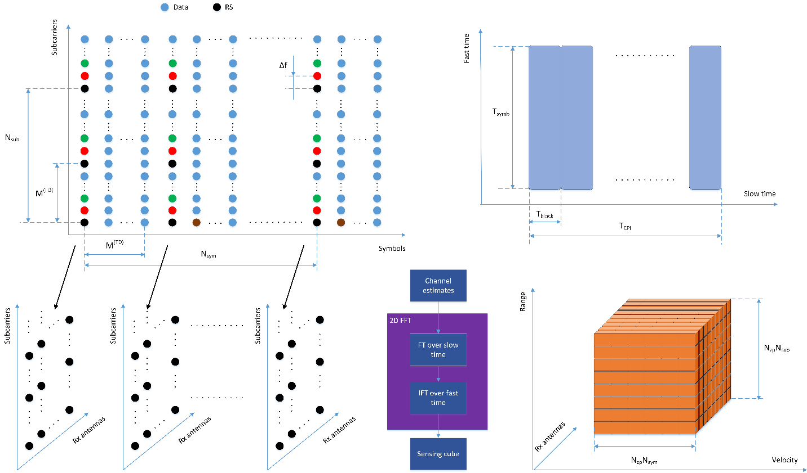
Figure 4. Structure of OFDM waveform and main steps of its processing
In a manner similar to communication systems, for a given sensing link, a set of sensing RSs is utilized at the receiver for channel estimation. These RSs are allocated to a unique set of subcarriers and OFDM symbols. The number of allocated subcarriers, N_{sub}, is determined by the signal bandwidth and the frequency-domain multiplexing factor M^{(FD)}. For example, if a 100 MHz bandwidth is considered, 273x12 = 3276 subcarriers are available. In the case where M^{(FD)}=2, the number of subcarriers allocated for sensing is N_{sub} = 1638. While various approaches to subcarrier allocation are possible, from the perspective of Fourier transform implementation, it is convenient to allocate subcarriers uniformly. Consequently, the well-established ‘comb’ approach to subcarrier allocation is needed.
As seen in Figure 4, the OFDM waveform consists of a sequence of OFDM symbols. The number of symbols allocated for sensing, N_{sym}, in combination with the time-domain multiplexing factor M^{(TD)} determines the total length of the waveform. The corresponding time interval T_{CPI} is known as the CPI. Given a subcarrier spacing of Δf = 30 kHz, the duration of an OFDM symbol (including the duration a normal cyclic prefix) is T_{symb} = 35.67 μs. Consequently, for N_{sym} = 256 and M^{(TD)} = 1, the resulting CPI is T_{CPI} = 9.1 ms.
The sensing RSs can be also leveraged for the communication purposes facilitating integrated operation. Furthermore, employing M^{(FD)}>1 and M^{(TD)}>1 enables orthogonal multiplexing in the frequency and time domains, respectively. This flexibility can be exploited to implement multiple concurrent sensing links and, specifically, multistatic sensing. Additionally, if a TRP performing the monostatic sensing is equipped with multiple Tx antennas, these multiplexing capabilities can be used to implement a virtual Rx antenna array. Such a virtual antenna array can increase the angular resolution of the sensing link far beyond the limits imposed by the physical dimensions of the Rx antenna array by creating a much larger effective aperture.
Observation 9: There needs to be means to support multiplexing of multiple sensing entities in a system level for high resource utilization.

The width of the main lobe of the range-Doppler response determines the range and velocity resolutions. Specifically, the range resolution is inversely proportional to the occupied signal bandwidth, B
$$∆R=\frac{c}{2B}$$ | (1)
Given N_{sub} = 3276 subcarriers spanning a bandwidth of B = 98.28 MHz, the range resolution is ΔR = 1.52 m. It is worth noting that as long as the comb approach to subcarrier allocation is used, the allocated subcarriers occupy the entire system bandwidth. Consequently, the range resolution remains constant regardless of the multiplexing factor M^{(FD)}.
For a given carrier frequency, the radial velocity resolution is determined by the duration T_{CPI} of CPI
$$∆v=\frac{λ}{2T_{CPI}}$$ | (2)
As follows from (2), a longer CPI is beneficial as it improves the velocity resolution. This observation is illustrated in Table 3, which summarizes the velocity resolution versus T_{CPI} for various carrier frequencies.
Table 3 Velocity resolution vs CPI duration
F_{c}, GHz | T_{CPI}, ms | 5 | 10 | 20 | 40 | 100 | 200
4.0 | Δv, km/h | 27.0 | 13.5 | 6.7 | 3.4 | 1.35 | 0.68
4.9 |  | 22.0 | 11.0 | 5.5 | 2.76 | 1.1 | 0.55
28 |  | 1.07 | 0.54 | 0.27 | 0.13 | 0.05 | 0.03
Target displacement, m |  | 0.25 | 0.5 | 1.0 | 2.0 | 5.0 | 10.0
It is evident a CPI of T_{CPI} = 200 ms provides a significant advantage compared to T_{CPI} = 5 ms, especially at lower carrier frequencies. This may be of crucial importance in scenarios where a slow-moving target must be detected in the presence of strong scattering from a static background object. When the ranges of the target and the background object are nearly identical, the non-zero velocity becomes the primary feature for target discrimination.
This scenario is illustrated in Figure 5. The true target range and velocity are R = 120 m and V_{r} = 6 km/h, respectively (indicated by the red circle). The static object is composed of a set of ‘bright’ points, spanning the range from 100 to 118 m. The left and right panels of Figure 5 correspond to N_{sym} = 128 (M^{(TD)}=1, T_{CPI} = 4.6 ms) and N_{sym} = 512 (M^{(TD)}=1, T_{CPI} = 18.3 ms), respectively. In both cases, the number of subcarriers allocated for sensing is fixed at N_{sub} = 3276 (M^{(FD)}=1).
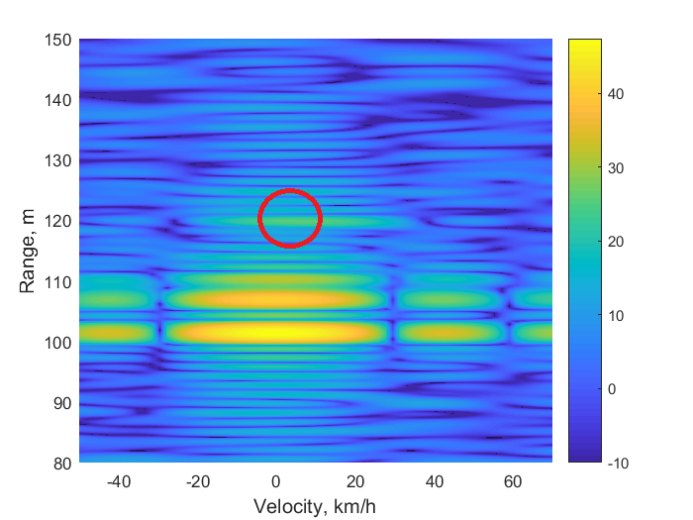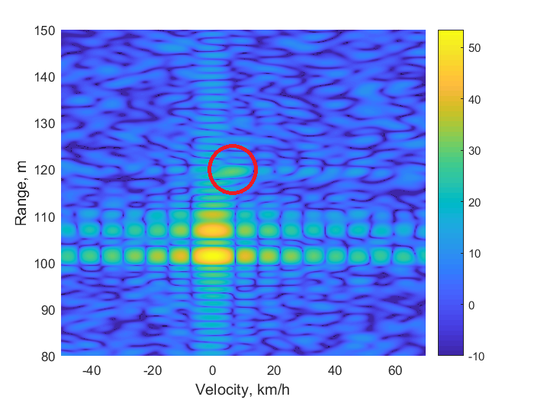
Figure 5 The range-Doppler response for a point target in the presence of strong scattering from a static object for T_{CPI} = 4.6 ms (left) and T_{CPI} = 18.3 ms (right)
It is evident that a longer CPI provides finer detail in the velocity domain. One might conclude that, unlike the signal bandwidth, the CPI duration is not strictly bounded. However, the design of OFDM-based sensing typically assumes a sufficiently short measurement interval such that target displacement remains negligible. Furthermore, if a target moves through multiple range bins during the CPI, the estimation performance degrades significantly. Consequently, the CPI must be constrained in practical applications.
The distance travelled by a target moving at 180 km/h during the CPI (T_{CPI}) is presented in Table 3. It is evident that for T_{CPI} = 200 ms, the target displacement reaches 10 m. However, as previously stated, the expected range resolution is only ΔR = 1.52 m. To mitigate range migration, a constraint must be placed on the maximum displacement and, consequently, on the allowable CPI duration.
Observation 10: The maximum target displacement during the CPI must be significantly less than the range resolution. To ensure this, the CPI duration may be constrained based on the range resolution and the maximum expected target velocity.

Sensing performance is strongly driven by signal-to-noise ratio (SNR) and correlation quality. To determine the sensing SNR at the receiver output, the radar equation can be utilized.
$$SNR_{m}=\frac{P_{tx}G_{tx}G_{rx}λ^{2}σ_{m}}{{\left(4π\right)}^{3}κTBN_{F}R^{4}}$$ | (3)
$$SNR_{b}=\frac{P_{tx}G_{tx}G_{rx}λ^{2}σ_{b}}{{\left(4π\right)}^{3}κTBN_{F}R_{tx}^{2}R_{rx}^{2}}$$ | (4)
where P_{tx} is the Tx power, G_{tx} is the Tx antenna gain, G_{rx} is the Rx antenna gain, σ_{m}, and σ_{b} are the monostatic and bistatic target RCS, B is the occupied signal bandwidth, N_{F} is the noise factor, R is the monostatic target range, R_{tx} and R_{rx} are Tx to target range and target to Rx range in bistatic. Equation (3), (4) are valid for a point target in free space in the presence of thermal noise.
Under the assumption sensing signal waveform is OFDM, there are inherent energy losses due to the cyclic prefix (CP). However, since the duration of a normal cyclic prefix is approximately 7% of the total OFDM symbol duration, these losses are only about 0.3 dB and can be neglected. More importantly, the OFDM processing provides a processing gain of
$$G_{OFDM}=N_{sub}N_{sym}$$ | (5)
Where N_{sub} and N_{sub} are the number of allocated subcarriers, number of subcarriers allocated for sensing.
As a result, the SNR at the output of the OFDM processor is given by
$${SNR}_{OFDM}=SNR{ G}_{OFDM}$$ | (6)
Based on (3) and assuming all available subcarriers in sensing bandwidth are allocated for sensing, a required processing gain can be assumed N_{sym} = N. In the case where the frequency-domain comb factor is doubled, the number of subcarriers is halved. Thus, to maintain the same processing gain, the number of OFDM symbols must be doubled (N_{sym} = 2N). However, this results in a longer CPI. Given a fixed CPI duration, the choice of multiplexing factors in frequency and time domain represents a trade-off between the achievable processing gain and the multiplexing capability.
If sensing RSs are frequency-multiplexed with data REs within the same OFDM symbol, transmit power must be distributed across both sensing and data REs. Such power splitting is undesirable given that sensing performance is strongly driven SNR. At the same time, allocating frequency resources to sensing within a data-carrying symbol inherently reduces the resources and power available for communication data transmission, which may degrade communication performance. RE-level Frequency Division Multiplexing (FDM) between sensing RSs and data REs could be therefore considered inefficient from both sensing and communication performance perspectives. A similar consideration applies to RE-level FDM between sensing RSs and communication RSs.
Observation 11: If the sensing signal and the communication signal are RE-level multiplexed in frequency domain, the sensing signal power may not be sufficient for sensing purpose.
Proposal 14: RAN1 studies whether to support RE-level FDM of sensing and communication signal in frequency domain.

Even if RE-level FDM between sensing and communication signals is not supported, FDM at a larger granularity, such as at the (sub-)band level, should be considered from a system perspective. Allocating an entire carrier exclusively for sensing or for communication may not always be feasible, as sensing demand and communication traffic can vary over time and across deployment scenarios. Allowing sensing and communication to operate in different frequency regions within the same carrier can therefore provide necessary flexibility, enabling sensing to utilize contiguous bandwidth while maintaining efficient use of spectrum for communication. Accordingly, RAN1 needs to study (sub-)band-level FDM methods for sensing and communication signals, including their impact on sensing performance, communication performance, and overall system operation.
Proposal 15: RAN1 studies FDM method of sensing and communication signal in different (sub)band.

With Time Division Multiplexing (TDM), sensing and communication transmissions are separated in time, for example by allocating one or more OFDM symbols intra‑ or inter‑slot (within a CPI) exclusively for sensing. RS patterns in the time domain can still contribute to reducing overall system overhead. By allowing non-uniform placement of sensing symbols over time, the number and periodicity of sensing-dedicated symbols can be adapted to sensing performance requirements, without unnecessarily increasing sensing resource allocation. As a result, time-domain pattern design is an important aspect to study for balancing sensing performance and overall resource efficiency, even when sensing-dedicated symbols are assumed.
Proposal 16: RAN1 studies the patterns of the sensing symbols in time domain.

In TRP-UE or UE-TRP bistatic sensing, the target sensing area may not coincide with the communication service area, leading to different preferred beam directions for sensing and communication. The TSA may be different with UE’s serving cell coverage, or in a direction where communication transmission is not required. Representative examples include UAV scenarios where sensing targets are located at similar or higher elevations than the TRP while communication primarily serves ground UEs, roadside or urban deployments where sensing targets are located in adjacent lanes or intersections outside the main communication beams, and industrial or campus environments where sensing focuses on safety-critical zones beyond the communication service area. In such cases, different beam directions are naturally preferred for sensing and communication.
In such scenarios, supporting simultaneous transmission of communication and sensing signals using multiple beams may introduce additional technical considerations. In particular, transmit power needs to be distributed across multiple beams, which can reduce the effective power per beam and impact both communication reliability and sensing detectability. Furthermore, the maximum number of simultaneously supported beams may be limited by practical constraints such as the number of antenna elements, RF chains, and beamforming capability, requiring careful allocation of antenna element resources between communication and sensing. Additional aspects, including inter-beam interference, beam isolation, and increased beam management complexity, may also need to be studied to enable efficient multi-beam operation for joint communication and sensing.
Observation 12: If the target sensing area is different from the communication area in TRP-UE/UE-TRP bistatic sensing, the beam direction for each can be different.
Proposal 17: RAN1 studies SDM method of sensing and communication signal.

In sensing operation, there can be scenarios where multiple sensing entities are required to transmit or receive sensing signals using the same time-frequency resources. Such situations may arise, for example, when multiple UEs or TRPs are instructed to sense a common target or a common TSA within a limited sensing occasion, or when sensing needs to be performed simultaneously to satisfy latency or update-rate requirements. In these cases, even when TDM or FDM is applied, different sensing entities may still end up using overlapping resources due to limited available sensing resources or coordination constraints. For instance, sensing entities may be configured to transmit sensing signals within the same CPI to enable joint or cooperative sensing, or multiple sensing receivers may need to listen to the same sensing transmission simultaneously.
To mitigate such resource contention and sensing-to-sensing interference, Code Division Multiplexing (CDM) can be considered as an additional multiplexing mechanism. By applying different codes or sequences to sensing signals, multiple sensing entities can share the same time-frequency resources while maintaining separability at the receiver. Therefore, RAN1 needs to study CDM methods as a means to improve multiplexing capability and reduce mutual interference in scenarios where multiple sensing entities access the same sensing resources.
Observation 13: There can be cases where multiple sensing entities try to access the same resource for their sensing Tx and Rx.
Proposal 18: RAN1 studies CDM method of sensing and communication signal.

RAN1 can study how to minimize the communication performance degradation or the resource sacrifice due to the introduction of sensing into the communication system. Instead of multiplexing (which naturally requires the sacrifice of the communication resource), the superposition of the communication and the sensing signal can be considered. Depending on the use cases, the Tx power can be flexibly split between communication and sensing. For example, at the center of the cell coverage, more power can be allocated to the sensing signal Tx as the SNR level is usually high in this area. The interference from the sensing signal to the communication can be easily removed by e.g., successive interference cancellation because the sensing signal is the known reference signal. At the edge of the cell coverage, the sensing signal power can be adjusted to low enough not to interfere with the communication signal reception. The insufficient power level of the sensing signal can be overcome through the repetition and combining scheme. The power split and the number of repetitions can be determined based on e.g., the distance from the TSA.
UE-UE bistatic sensing is also important sensing mode in that it can be used for extending the sensing coverage or improving the sensing performance. RAN1 needs to study how to support UE-UE bistatic sensing without using sidelink connection. For example, UL signals or resources can be used for UE-UE bistatic sensing. In this case UE as sensing entity can be selected based on distance to/from Target Sensing Area (TSA), receive signal power level/RSRP, or bistatic angle estimation. The information about those UEs can be exchanged between sensing Tx and Rx UEs. The UL signals used for UE-UE bistatic sensing can be configured by BS or SF, or UE-TRP bistatic sensing signal can be overheard by another UE, which results in UE-UE bistatic sensing. In the former case, Rx UE can be explicitly configured by BS or SF, while in the latter case, Rx UE can be opportunistically determined by reporting the measurement results based on specific conditions.
Observation 14: Under TDD resource configuration, UL resources can be used for UE-UE bistatic sensing.
Proposal 19: RAN1 studies which resources of TDD resource configuration can be used for UE-UE bistatic sensing mode.

One of the issues regarding TRP-TRP bistatic sensing is the sensing signal resource allocation. In TRP-TRP bistatic sensing case, there could be some issues regarding the Tx/Rx operation in DL/UL resources if TDD resource multiplexing scheme is used. Conventionally such TDD configuration is configured as same across BS/TRPs so that the crosslink interference (CLI) can be minimized. Under this resource configuration, if Tx TRP send a sensing signal in DL resource, Rx TRP should receive the sensing signal in DL resource, which is not the nominal operation expected for BS/TRP in DL resource. For Rx TRP to receive the sensing signal in UL resource, Tx TRP should also use the UL resource to transmit the sensing signal, which again violates the conventional Rx operation for BS/TRP in UL resource. There are some solutions to this issue. For example, sensing-specific resources can be separately configured from DL/UL resources. The other way is to configure Tx TRP’s DL resources to overlap with Rx TRP’s UL resources only for sensing purpose. There are similar issues of so-called Remote Interference Management (RIM) where such overlap happens by the environment. Another way is to repurpose UL or DL resource for transmission or reception respectively. RAN1 needs to study how to handle this resource allocation issue for TRP-TRP bistatic sensing.
Observation 15: Need to study which resources can be used for TRP-TRP bistatic sensing.
Proposal 20: RAN1 studies the resource allocation for TRP-TRP bistatic sensing.

    - Phase continuity within a CPI
In sensing systems, the coherent processing interval (CPI) is directly related to Doppler resolution, and depending on the use case, a CPI may be configured over multiple symbols and/or slots. In order to perform coherent integration over the entire CPI, it is important to maintain phase and power continuity across the CPI. If phase continuity is not guaranteed within the CPI, several issues may occur, such as Doppler estimation bias due to an arbitrary phase jump, loss of coherent integration gain, degradation of resolution due to CPI segmentation, and false target detection.
In existing communication systems, PUSCH/PUCCH repetition has been introduced for coverage enhancement. For such repetition-based operations, the importance of phase continuity and power consistency has been considered, for example, in DMRS bundling for joint channel estimation over multiple slots. To this end, events where phase continuity or power consistency cannot be guaranteed have been specified, such as beam/precoder switching, DL/UL switching, carrier frequency or LO changes including CA-related changes, RF/PA state transitions, transmission gaps, and resource reconfiguration. Similar types of events may also occur in the context of sensing signal transmission. Therefore, taking the events considered for existing communication operations as a baseline, sensing-specific events where phase continuity or power consistency of sensing signals cannot be assumed could be considered.
A CPI may need to be configured over multiple slots, possibly over several tens of milliseconds, in order to satisfy velocity estimation requirements. In such a case, as one example, the sensing transmitter may not be able to receive signals during the CPI in order to maintain phase continuity, which may result in significant time-domain overhead. Therefore, for ISAC systems, methods and procedures for maintaining phase and power continuity at the transmitter need to be studied. In addition, compensation methods and procedures need to be studied for cases where phase and/or power discontinuity occurs.
Proposal 21: Study how to address the phase/power discontinuity within a CPI.

    - Beam related sensing operation
The communication-centric beam management procedure is fundamentally driven by the objective of maximizing received signal quality at the UE and ensuring robustness of the communication link. As a result, beam selection, measurement, and reporting are closely tied to communication-oriented performance metrics and UE-centric link quality optimization. In contrast, sensing beam alignment should be performed with other aspects. The sensing beams between sensing Tx and sensing Rx can be aligned based on TSA. For example, the sensing Tx can transmit beam toward TSA and the sensing Rx can also form a Rx beam toward TSA. The beam sweeping operation can be done only related to TSA, and based on e.g., best RSRP, the sensing Tx and Rx can align their beams together.
If a single beam is used for both communication and sensing (e.g., the communication RS is reused for sensing purpose), the beam direction can be determined considering both directions to communication UE and TSA. At the same time, the beam width of the Tx signal can also be determined based on the angle gap between two directions above. For example, if the angle gap is small (that is, both directions are very close) a narrow beam can be used for both communication and sensing. If the angle gap is relatively large, then a wider beam needs to be used to cover both directions. RAN1 needs to study the direction and width of Tx beam when Tx signals are shared between communication and sensing.
This TSA-centric perspective also affects the definition of candidate beams. Communication beams are typically selected to cover UE locations and mobility patterns, whereas sensing beam candidates may need to cover specific delay/Doppler/angle range of target, or regions inside or outside the serving cell, depending on TSA. In bistatic sensing scenarios, a beam that maximizes communication link quality may not illuminate or observe the TSA. Conversely, a beam that is well aligned with the TSA may experience reduced received power at the receiver due to blockage, scattering, or non-line-of-sight propagation, and therefore may be considered sub-optimal or even unusable from a communication perspective. For sensing, reduced received power caused by interaction with a TSA or environment objects does not necessarily indicate an undesirable beam. This indicates that sensing beam management may require mechanisms that differ from those used for communication beam management.
While this concept is intuitive, it implies that beam management procedures from a sensing perspective need to differ from those designed for communication. Sensing may require fine grained acquisition of the spatial channel structure between the sensing Tx and Rx, aiming to estimate per path or per scatterer parameters (delay, Doppler, angle, amplitude) rather than relying on averaged total power over radio resources per beam. At the physical layer, beams constitute the primary spatial resource, and fine-grained beam control enables estimation of detailed spatial channel parameters relevant to TSA and target objects.
Therefore, procedures to manage beams from a sensing perspective could be discussed and enable the system to:
- Identify and separate the target induced paths or points (i.e., the subset of multipath components associated with a region or object of interest) from non-target/background paths or points (i.e., multipath components associated with regions or objects outside the sensing interest)
- Search and select beams to maximize observability in the angle/time/Doppler domains and improve parameter accuracy, not only data throughput.
Particularly, sensing-centric beam management may require interference-aware sweeping to minimize signals from non-target objects, sensing-quality monitoring to maintain observability, and background/TSA awareness to focus sensing resources on regions of interest. Furthermore, beam update and adjustment rules for sensing may differ from communication beam recovery logic. While communication beam switching is typically triggered by link degradation or beam failure events, sensing beam adjustment may be triggered by changes in sensing objectives, target dynamics, or sensing performance requirements, even when the communication link remains stable. This implies that sensing-aware beam adjustment may operate independently of, or in parallel with, communication beam management, and that appropriate coordination may be required to avoid conflicting beam decision.
Proposal 22: Study the sensing related beam operation.

    - Interference handling
As 6G sensing mode include bi-static configurations, interference management can be important aspect to ensure reliable sensing performance. In particular, sensing reception may be significantly affected by transmissions that are not directly associated with the intended sensing operation, especially when sensing relies on weak reflections from target objects or environment objects. Without appropriate control of such transmissions, strong signals from other transmitting entities may dominate the received signal, thereby masking sensing echoes and degrading detectability. In this context, muting operation can be considered as a potential mechanism to improve sensing performance by intentionally suspending or restricting transmissions from certain transmitting points during specific time resources. When sensing requires the involvement of multiple sensing entities—such as multiple TRPs (including neighboring BSs) or multiple UEs contributing sensing transmissions or sensing observations—the need for muting could be more important. In such cases, sensing reception at a given node may overlap in time-frequency with transmissions from other entities that are not directly contributing to the sensing objective. For example, when sensing reception relies on signals from a neighbor cell or distant TRP, muting transmissions from the serving cell or nearby TRPs may be considered to compensate for additional path loss and to improve the detectability of weak sensing echoes.
Proposal 23: RAN1 studies the necessity of configuring a muting pattern.

If dedicated sensing resources are introduced or supported in 6G ISAC systems, the configuration of a measurement gap for sensing may need to be considered. In NR positioning operation, measurement gaps are used to allow positioning signal reception to be performed with high priority, without assuming reception of communication signals during the gap. During such gaps, positioning-specific frequency resources, often referred to as a positioning frequency layer, can be configured, enabling selection of frequency bandwidth independently of the communication bandwidth part (BWP). This allows positioning accuracy to be improved without being constrained by communication resource configuration. Similarly, in sensing operation, measurement gap configurations may enable the allocation of sensing-specific bandwidth independently. By configuring sensing-dedicated frequency resources, sensing operation can exploit more suitable bandwidth, which may improve measurement resolution. Therefore, it is necessary to study how measurement gap concepts and associated resource configurations can be applied to sensing, while considering their impact on communication operation and overall system efficiency.
Proposal 24: RAN1 studies the necessity of configuring a measurement gap for sensing.

When considering the possibility that a sensing RS is transmitted within a 6G communication symbol, additional physical-layer aspects need to be carefully studied. In particular, the coexistence of sensing RS and communication signals within the same OFDM symbol introduces new design considerations that are not present when sensing resources are fully separated in time or frequency.
Interference from communication signals to the sensing RS is another important aspect to be studied. When sensing RS and communication signals coexist within the same symbol, communication REs may act as structured interference to the sensing RS at the sensing receiver. This interference may degrade sensing observability, parameter estimation accuracy, or detection sensitivity, even if communication performance remains acceptable. In addition, when data REs and the sensing RS are mapped to adjacent frequency resources within the same OFDM symbol (e.g., adjacent subcarriers), inter-carrier interference (ICI) may occur due to non-ideal spectral containment or practical transmitter and receiver impairments such as phase noise, carrier frequency offset, imperfect synchronization. As sensing performance often relies on precise amplitude and phase information for parameter estimation in the delay, angle, and Doppler domains. Even moderate ICI levels that are tolerable for communication may lead to noticeable degradation in sensing performance Therefore, it is necessary to study how such interference should be handled, for example through RE mapping rules, power allocation strategies.
Proposal 25: If a sensing RS is agreed to be transmitted in 6G communication symbol, RAN1 needs to study whether/how to handle the interference from the communication REs to the sensing RS.

    - Power control
In NR communication systems, explicit standardized power control procedures are mainly defined for uplink transmissions. For downlink transmissions, the transmit power of DL signals and channels is generally determined by the gNB implementation and associated configurations. For ISAC systems, however, sensing signal power control may not be sufficiently characterized only by the transmission direction, i.e., uplink or downlink. This is because the received power relevant for sensing may correspond to a target-scattered or reflected path, rather than the direct link between the sensing transmitter and the sensing receiver. In other words, the power control reference for sensing may be different from the received signal power conventionally used for communication link adaptation or interference control.
Moreover, the relevant propagation path, received power metric, and power control objective may depend on the sensing mode. For monostatic sensing, the transmit power may need to be controlled considering the echo power from the target, self-interference, receiver dynamic range, clutter. For bistatic sensing, the transmit power may need to be controlled considering the target-scattered signal power observed at a separate sensing receiver, as well as the sensing Tx-target-Rx geometry. For cooperative sensing, the transmit power may need to be controlled considering the received target-channel powers at multiple sensing receivers, inter-node interference, and the relative measurement quality among different observation points.
Proposal 26: RAN1 studies sensing signal transmission power control from the perspective of the
sensing mode.

One important aspect for sensing signal power control is that the received power relevant for sensing may be different from the received power conventionally used for communication power control or link quality assessment. In general, the sensing signal Tx power cannot be controlled based on RSRP of the sensing Rx because such RSRP includes very strong LOS component between sensing Tx and sensing Rx. Such LOS component is of the main interest in communication to determine the communication performance. However, such LOS signal is just background interference from sensing perspective, which should be suppressed by sensing Rx. Instead, the sensing signal scattered by the target objects is most important to sensing Rx. In this sense, the sensing signal Tx power needs to be controlled based on the target channel power measured by the sensing Rx. Sensing Rx can report only Rx power of the target channel to sensing Tx so that sensing Tx can control the sensing signal Tx power to achieve the required Rx signal quality. Another possibility is to control sensing signal Tx power based on the distance between the TSA and the sensing Tx and/or Rx. RAN1 needs to study how to handle sensing signal Tx power control.
Another possible way of controlling the ‘effective’ Tx power is to use the number of repetitions of the sensing signal. For example, if the sensing signal power is restricted below some level for any reason (e.g., interference avoidance to the nearby UE communication), the alternative solution may be increasing the number of the sensing signal transmission so that the sensing Rx get the processing gain of the sensing signal.
If both sensing and communication beams are used simultaneously, then Tx power needs to be split to both signals while keeping the max. Tx power requirement. This may lower either sensing or communication Tx power, which in turn may degrade either sensing or communication performance. One of the possibilities is to restrict transmitting both communication and sensing signal simultaneously into the case where the direction gap between communication and sensing is not so large. Otherwise, the sensing Tx can transmit each signal sequentially in time domain. In this case, the Tx power control parameters (e.g., P0 and alpha) can be separately configured for each transmission.
Proposal 27: RAN1 studies how to control the sensing signal transmission power.

When a sensing RS is transmitted in communication symbol, the transmit power of the sensing RS requires further study. In a communication symbol, transmit power is evenly distributed across multiple REs carrying data and RSs, following communication-oriented power allocation principles. If the communication RS is reused as a sensing RS or a sensing RS is mapped to a subset of REs within such a symbol, it is not clear whether the default power allocation would be sufficient to meet sensing performance requirements, especially when target-related reflections are weak. This motivates the need to study whether power boosting of the sensing RS is necessary, and if so, how such power boosting can be applied without adversely impacting communication signals and which level it could be applied.
Proposal 28: If a sensing RS is agreed to be transmitted in 6G communication symbol, RAN1 needs to study whether/how to apply power boosting of the sensing RS.

    - Timing advance
In the existing communication framework, Timing Advance (TA) is primarily used to ensure that UL signals transmitted from multiple UEs are received within the CP at the BS, thereby reducing inter-symbol interference (ISI). Applying TA to sensing signal transmission may provide similar benefits, as sensing signals transmitted by UEs can be aligned at the receiving TRP, reducing ISI among sensing signals and simplifying receiver processing. Furthermore, in UE-TRP bistatic sensing scenarios, sensing signals transmitted by a UE may need to be received by multiple cells or TRPs. In such cases, it is not obvious which reference should be used for TA configuration, since propagation delays to different receiving TRPs can differ. Given these aspects, RAN1 needs to study the necessity and applicability of timing advance for sensing, including UE-TRP bistatic sensing, and to assess whether existing TA mechanisms can be reused or whether additional sensing-specific considerations are required.
Proposal 29: RAN1 studies the necessity of applying timing advance, e.g., for UE-TRP bistatic sensing.

    - Others
RAN1 needs to study the bistatic sensing case where the neighbor cell TRP can be involved depending on the location of the TSA. This may happen if UE is camping on a serving cell, but TSA is closer to the neighbor cell TRP. One of the conclusions from 5GA ISAC SI is that a single TRP based sensing may not provide sufficient sensing performance, especially in terms of miss detection and false alarm probability. To achieve QoS target for sensing, multi-static sensing is considered as one of the solutions. For multi-static sensing where multiple TRPs are involved as sensing Tx or Rx, UE needs to know which TRPs are sensing entities to perform multi-static sensing. This information is necessary for sensing signal Tx/Rx resource scheduling, sensing beam alignment, etc.
If the TRP does not belong to UE’s serving cell, there needs to be the means on how sensing signal Tx/Rx resources can be scheduled and how the sensing beam can be aligned between UE and those neighbor cell’s TRPs. For example, the serving cell can deliver such TRPs’ information to UE, and vice versa. For the sensing signal resources, RACH-related resources can be considered to be used without explicit scheduling between UE and neighbor TRPs for UE-TRP bistatic sensing. One of the issues may be the timing advance that Tx UE applies to sensing signal Tx. For example, it can be determined based on RSRP values from the serving cell and the neighbor cell.

- Conclusions
In this contribution, the issues related to the RS design, Tx/Rx/measurement/reporting and physical layer procedure for 6G ISAC were discussed. The following observations and proposals were made as conclusions.
Observation 1: It is beneficial for sensing waveform to be aligned with 6G baseline communication waveform in terms of ISAC system implementation complexity.
Observation 2. Comb-type RE mapping with a uniform spacing in the frequency domain may cause range ambiguity in target detection.
Observation 3. A non-uniform RE pattern in the frequency domain can mitigate range ambiguity in target detection.
Observation 4: 5G-A ISAC measurement level A and B require huge amount of signaling overhead, compared to level C and D.
Observation 5: Within a monostatic configuration, the localization of a target in 3D physical space may require the simultaneous estimation of four parameters: target range, radial velocity and both azimuth and zenith angles.
Observation 6: Within a bistatic configuration, the localization of a target in 3D physical space may require the simultaneous estimation of four parameters: bistatic range, bistatic velocity and the AoA defined by the azimuth and zenith angles at the receiver.
Observation 7: The details of the measurement metric for monostatic and bistatic sensing may be different.
Observation 8: Assistant information in addition to the measurement report should assist SF to further identify/classify the detected object.
Observation 9: There needs to be means to support multiplexing of multiple sensing entities in a system level for high resource utilization.
Observation 10: The maximum target displacement during the CPI must be significantly less than the range resolution. To ensure this, the CPI duration may be constrained based on the range resolution and the maximum expected target velocity.
Observation 11: If the sensing signal and the communication signal are RE-level multiplexed in frequency domain, the sensing signal power may not be sufficient for sensing purpose.
Observation 12: If the target sensing area is different from the communication area in TRP-UE/UE-TRP bistatic sensing, the beam direction for each can be different.
Observation 13: There can be cases where multiple sensing entities try to access the same resource for their sensing Tx and Rx.
Observation 14: Under TDD resource configuration, UL resources can be used for UE-UE bistatic sensing.
Observation 15: Need to study which resources can be used for TRP-TRP bistatic sensing.

Proposal 1: RAN1 studies and identifies whether/which communication procedures can benefit from sensing-derived information.
Proposal 2: RAN1 studies whether/how sensing signal/measurement/report can assist communication system.
Proposal 3: If (DFT-s-) OFDM is agreed as a sensing waveform, RAN1 studies the type of a sensing RS of (DFT-s-) OFDM symbol.
Alt 1. Reuse the 6G communication RS pattern
Alt 2. Enhance the 6G communication RS pattern
Alt 3. Design a new RS pattern for sensing
Proposal 4: If 6G communication RS pattern is enhanced for sensing, RAN1 needs to study the impact of RS enhancement to the communication system, which may need cooperation with the relevant 6G agenda.
Proposal 5: If 6G communication RS pattern is reused, RAN1 needs to identify the type of symbol to include the sensing RS.
Alt 1. Transmitted in 6G communication symbol
Alt 2. Transmitted in a separate sensing symbol
Alt 3. Both depending on use cases
Proposal 6: If 6G communication RS pattern is enhanced, RAN1 needs to study the exact method of enhancement.
Alt 1. Extension of 6G communication RS parameters
Alt 2. Addition of new RS pattern to 6G communication RS
Proposal 7. RAN1 studies non-uniform RS RE patterns in the frequency domain for mitigating ambiguity problems in target detection.
Proposal 8: 5G-A ISAC measurement level C is considered as baseline, and level D as optional for 6GR sensing measurement.
Proposal 9: RAN1 studies the types of the measurement report.
Proposal 10: RAN1 studies how to reduce the signaling overhead for the measurement report.
Proposal 11: Study measurement reports for Mobility support.
Proposal 12: RAN1 studies the detailed measurement method of monostatic and bistatic sensing.
Proposal 13: Study what assistance information related to the measurement needs to be additionally reported.
Proposal 14: RAN1 studies whether to support RE-level FDM of sensing and communication signal in frequency domain.
Proposal 15: RAN1 studies FDM method of sensing and communication signal in different (sub)band.
Proposal 16: RAN1 studies the patterns of the sensing symbols in time domain.
Proposal 17: RAN1 studies SDM method of sensing and communication signal.
Proposal 18: RAN1 studies CDM method of sensing and communication signal.
Proposal 19: RAN1 studies which resources of TDD resource configuration can be used for UE-UE bistatic sensing mode.
Proposal 20: RAN1 studies the resource allocation for TRP-TRP bistatic sensing.
Proposal 21: Study how to address the phase/power discontinuity within a CPI.
Proposal 22: Study the sensing related beam operation.
Proposal 23: RAN1 studies the necessity of configuring a muting pattern.
Proposal 24: RAN1 studies the necessity of configuring a measurement gap for sensing.
Proposal 25: If a sensing RS is agreed to be transmitted in 6G communication symbol, RAN1 needs to study whether/how to handle the interference from the communication REs to the sensing RS.
Proposal 26: RAN1 studies sensing signal transmission power control from the perspective of the sensing mode.
Proposal 27: RAN1 studies how to control the sensing signal transmission power.
Proposal 28: If a sensing RS is agreed to be transmitted in 6G communication symbol, RAN1 needs to study whether/how to apply power boosting of the sensing RS.
Proposal 29: RAN1 studies the necessity of applying timing advance, e.g., for UE-TRP bistatic sensing.

- References
- 3GPP RAN1 #124bis chair notes
- 3GPP R1-2602592, Summary #4 on integration with communication for ISAC.
- 3GPP TR 38.914, RP-260073, Study on 6G scenarios and requirements (Release 20), V0.4.0.
- 3GPP TR 38.765, Study on Integrated Sensing and Communication (ISAC) for NR.
- 3GPP R1-2601385, Summary #6 on evaluations for NR ISAC.
- 3GPP TS 38.215, 5G NR Physical layer measurements.
- 3GPP TR 23.700-14, Study on Integrated Sensing and Communication; Stage 2.

